CHAPTER 4
DATA ANALYSIS AND INTERPRETATION

This chapter presents the analysis and interpretation of data collected from 110 nursing students through a structured self-administered questionnaire. Data were collected from July 3 to July 22, 2026. Findings are organized under four headings: demographic profile, practice related to digital device usage, symptoms of digital eye strain, and preventive practices and awareness.

4.1 Demographic Profile of the Participants
Table 4.1: Distribution of Participants by Age Group
Age Group | Frequency (n) | Percentage (%)
17-18 years | 9 | 8.2
19-20 years | 53 | 48.2
21-22 years | 46 | 41.8
>22 years | 2 | 1.8
Total | 110 | 100.0

Figure 4.1: Age Group Distribution
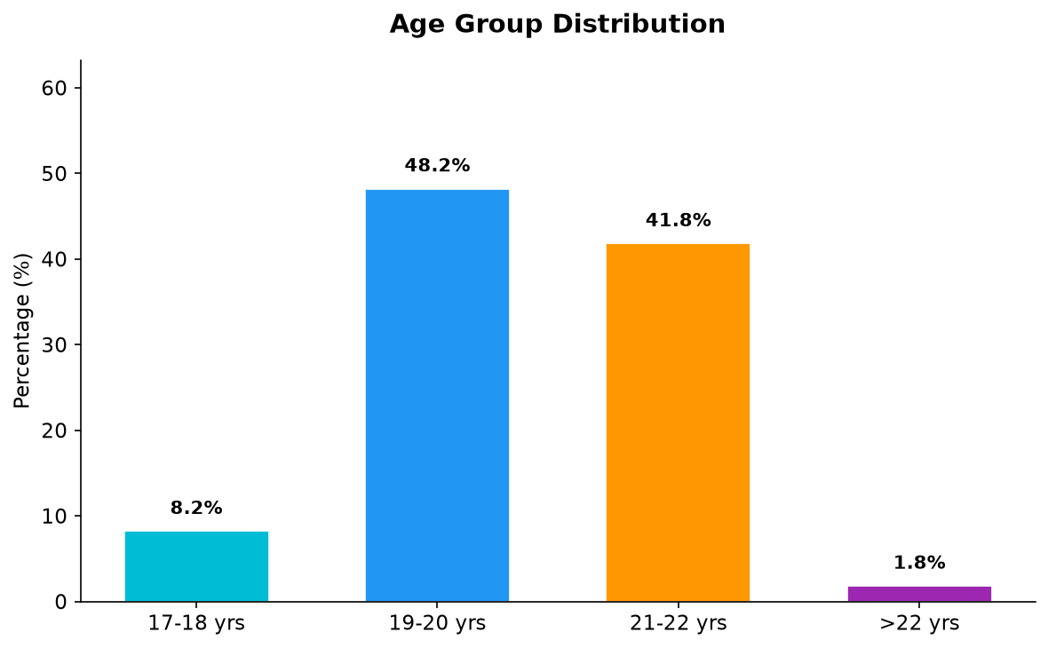

Interpretation: The majority of participants (48.2%) were in the 19-20 years age group, followed by 21-22 years (41.8%).
Table 4.2: Distribution of Participants by Gender
Gender | Frequency (n) | Percentage (%)
Female | 64 | 58.2
Male | 46 | 41.8
Total | 110 | 100.0

Figure 4.2: Gender Distribution
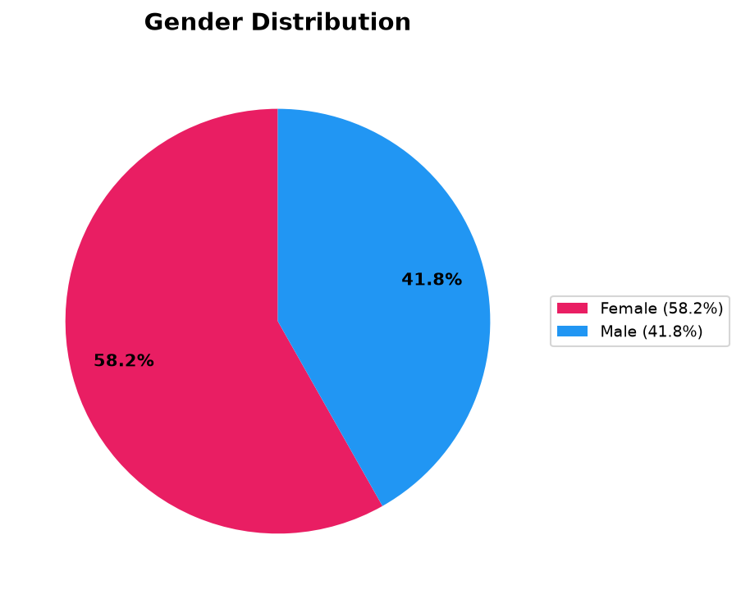

Interpretation: 58.2% were female, consistent with nursing education demographics.
Table 4.3: Distribution of Participants by Semester
Semester | Frequency (n) | Percentage (%)
1st | 8 | 7.3
2nd | 69 | 62.7
3rd | 20 | 18.2
4th | 1 | 0.9
5th | 4 | 3.6
6th | 3 | 2.7
8th | 5 | 4.5
Total | 110 | 100.0

Figure 4.3: Semester Distribution
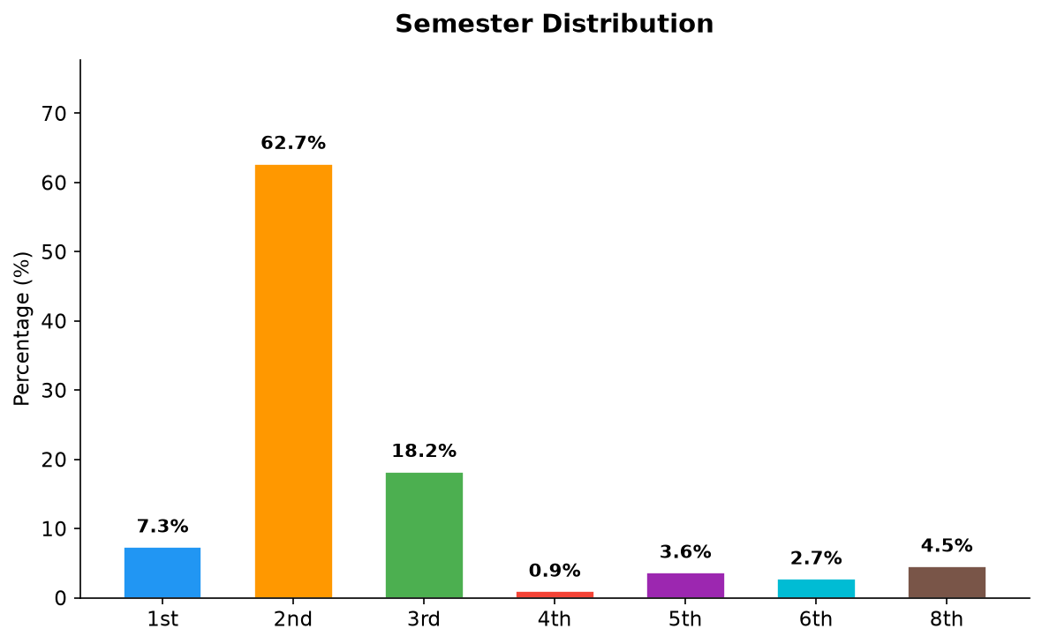

Interpretation: 62.7% were in the 2nd semester, the foundational year.
Table 4.4: Distribution of Participants by Type of Residence
Type of Residence | Frequency (n) | Percentage (%)
Home | 51 | 46.4
Hostel | 39 | 35.5
PG/Other | 20 | 18.2
Total | 110 | 100.0

Figure 4.4: Type of Residence
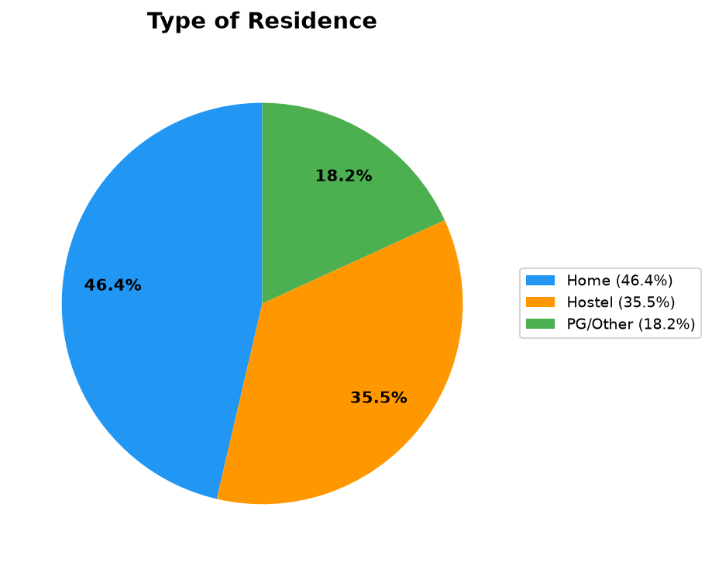

Interpretation: Varied living conditions may influence device usage patterns.
Table 4.5: Distribution of Participants by Average Daily Time Spent on Digital Devices
Average Daily Time | Frequency (n) | Percentage (%)
<2 hours | 14 | 12.7
2-4 hours | 32 | 29.1
4-6 hours | 41 | 37.3
>6 hours | 23 | 20.9
Total | 110 | 100.0

Figure 4.5: Average Daily Time on Digital Devices
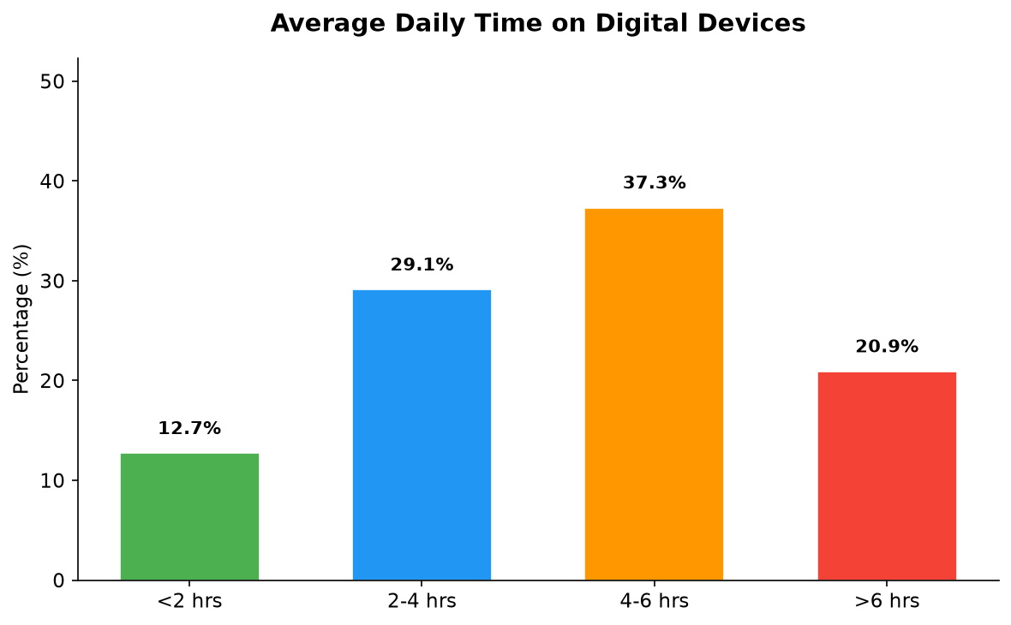

Interpretation: 87.3% spend 2+ hours daily on digital devices, at DES risk.
Table 4.6: Distribution of Participants by Main Device Used for Studies
Main Device | Frequency (n) | Percentage (%)
Smartphone | 66 | 60.0
Laptop | 35 | 31.8
Tablet | 6 | 5.5
Desktop | 3 | 2.7
Total | 110 | 100.0

Figure 4.6: Main Device Used for Studies
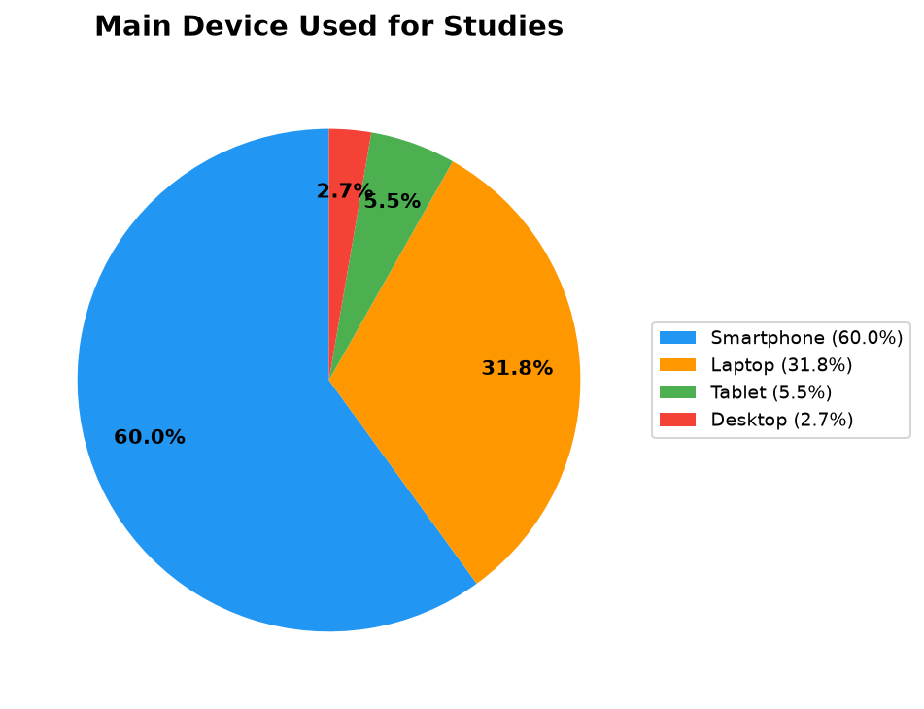

Interpretation: Smartphones dominate (60.0%), posing higher DES risk due to smaller screens.
Table 4.7: Distribution of Participants by Average Continuous Screen Time Without Break
Continuous Screen Time | Frequency (n) | Percentage (%)
<30 min | 27 | 24.5
30-60 min | 45 | 40.9
1-2 hrs | 27 | 24.5
>2 hrs | 11 | 10.0
Total | 110 | 100.0

Figure 4.7: Continuous Screen Time Without Break
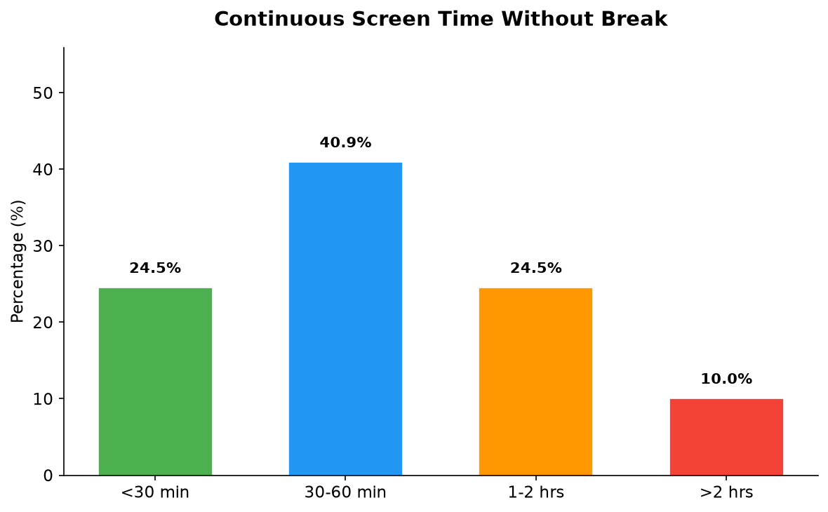

Interpretation: 34.5% use devices continuously for more than 1 hour without a break.
Table 4.8: Distribution of Participants by Total Daily Screen Exposure
Total Daily Screen Exposure | Frequency (n) | Percentage (%)
<3 hours | 26 | 23.6
3-5 hours | 37 | 33.6
5-8 hours | 28 | 25.5
>8 hours | 19 | 17.3
Total | 110 | 100.0

Figure 4.8: Total Daily Screen Exposure
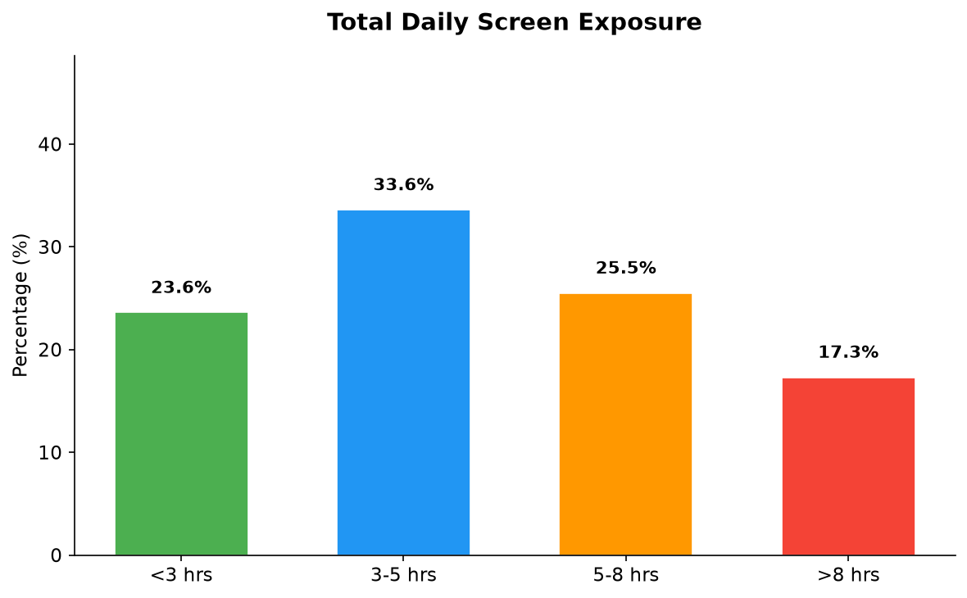

Interpretation: 76.4% have total daily exposure exceeding 3 hours.

4.2 Practice Related to Digital Device Usage
Table 4.9: Use of Digital Devices in Dark/Low Light
Response | Frequency (n) | Percentage (%)
Yes | 84 | 76.4
No | 26 | 23.6
Total | 110 | 100.0

Figure 4.9: Use of Devices in Dark/Low Light
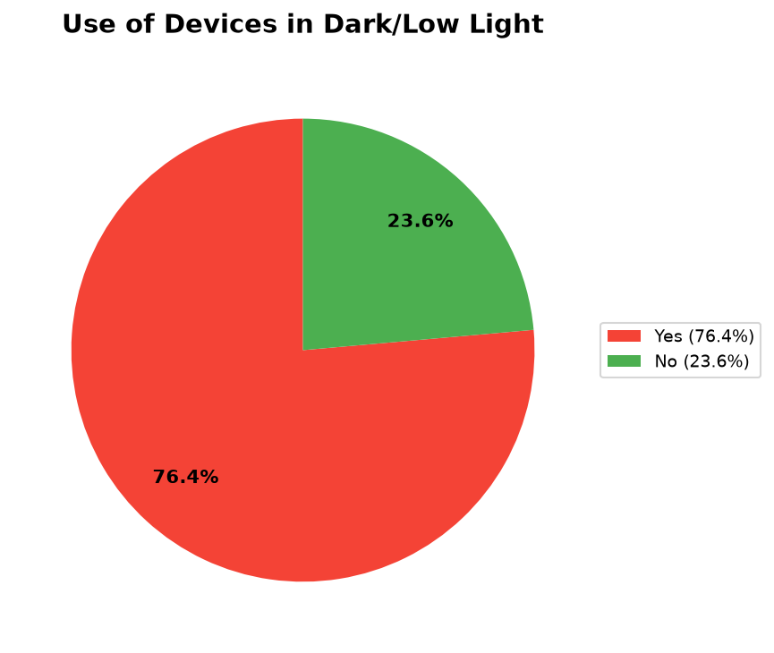

Interpretation: 76.4% used devices in dark environments, significantly increasing DES risk.
Table 4.10: Use of Devices While Lying Down
Response | Frequency (n) | Percentage (%)
Yes | 91 | 82.7
No | 19 | 17.3
Total | 110 | 100.0

Figure 4.10: Use of Devices While Lying Down
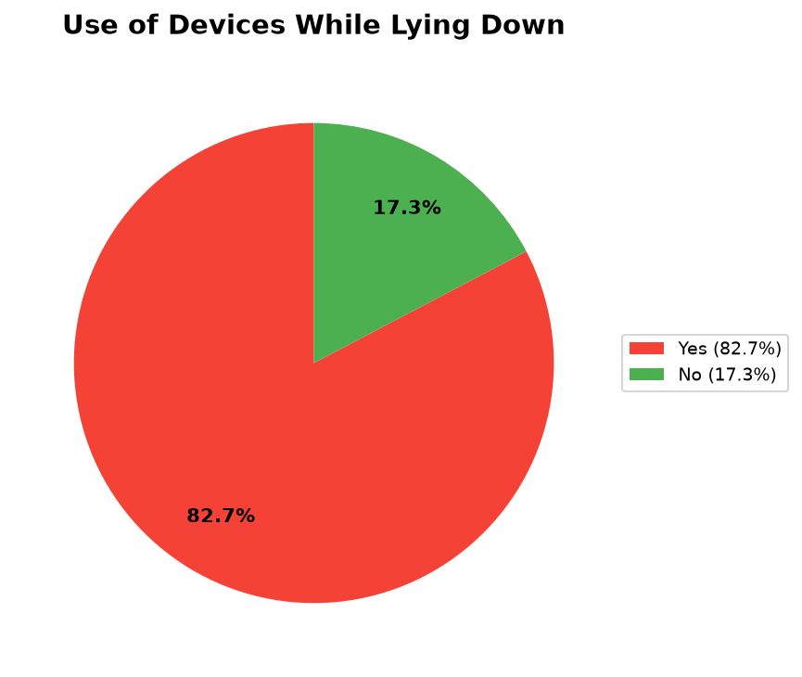

Interpretation: 82.7% used devices while lying down, leading to poor ergonomics.
Table 4.11: Taking Breaks During Long Screen Use
Response | Frequency (n) | Percentage (%)
Yes | 71 | 64.5
Sometimes | 27 | 24.5
No | 12 | 10.9
Total | 110 | 100.0

Figure 4.11: Taking Breaks During Screen Use
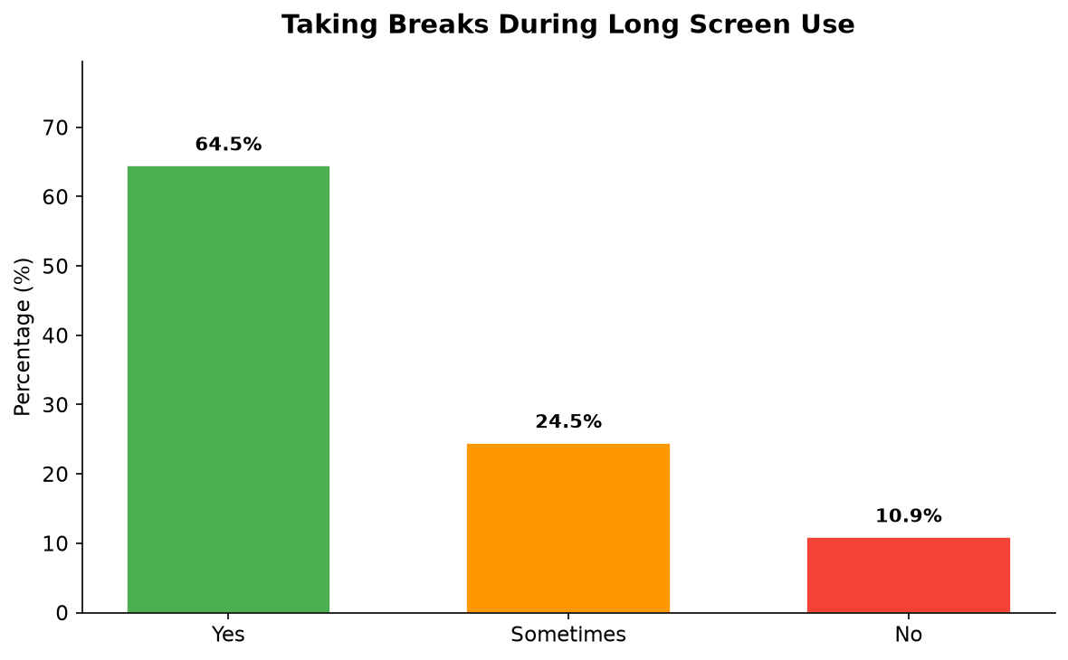

Interpretation: 35.4% had inconsistent or no break-taking habits.
Table 4.12: Use of Blue Light Filter/Night Mode
Response | Frequency (n) | Percentage (%)
Yes | 69 | 62.7
No | 41 | 37.3
Total | 110 | 100.0

Figure 4.12: Use of Blue Light Filter
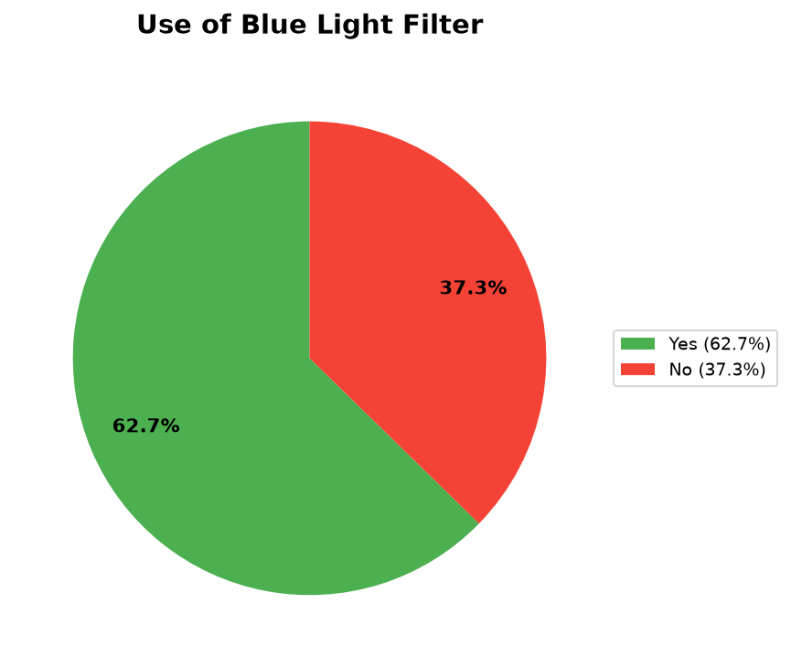

Interpretation: 37.3% did not use blue light filtering technology.
Table 4.13: Following the 20-20-20 Rule While Using Digital Devices
Response | Frequency (n) | Percentage (%)
Never | 39 | 35.5
Sometimes | 36 | 32.7
Rarely | 29 | 26.4
Always | 6 | 5.5
Total | 110 | 100.0

Figure 4.13: Following 20-20-20 Rule
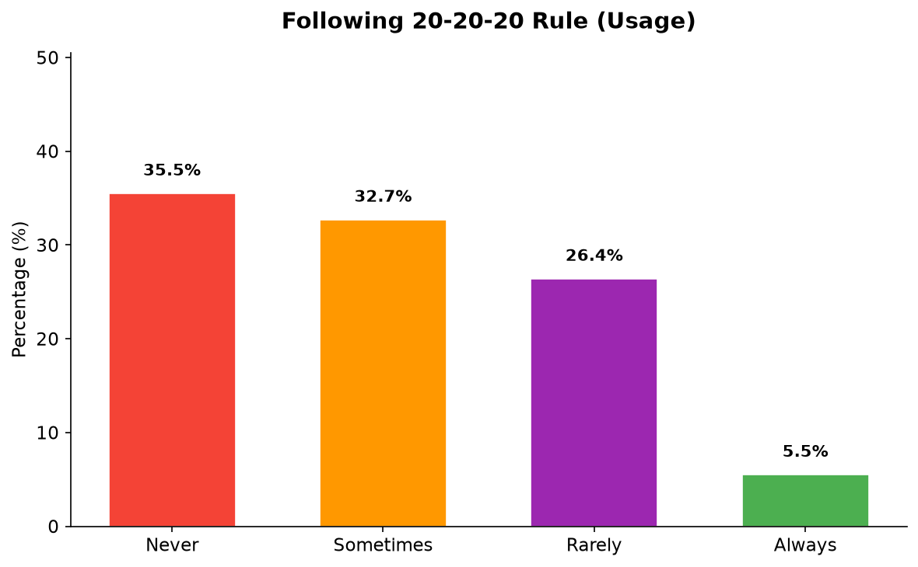

Interpretation: Only 5.5% always followed the 20-20-20 rule — a critical finding.

4.3 Symptoms of Digital Eye Strain
Figure 4.14: Overview of DES Symptoms Prevalence (Experiencing vs Never)
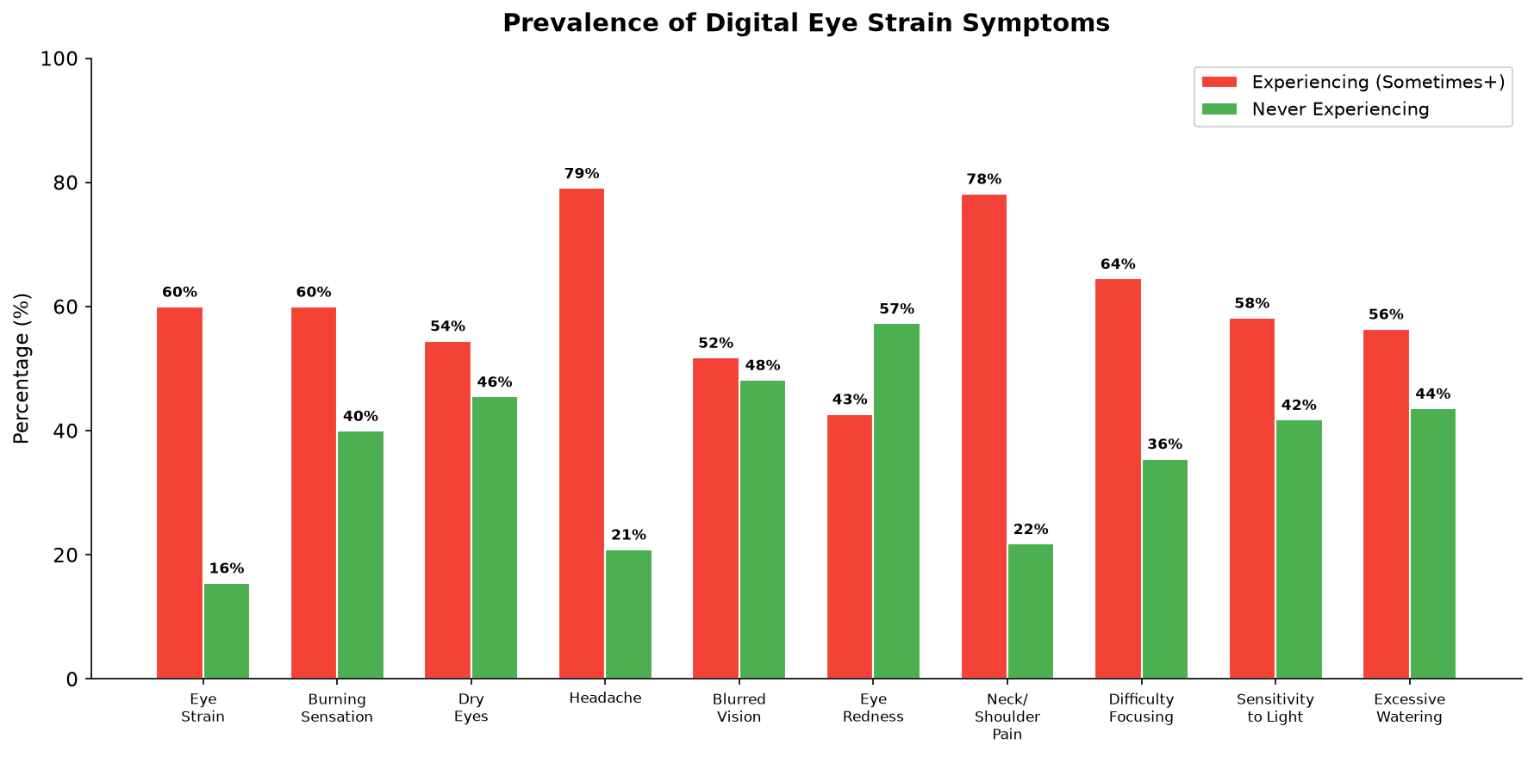

Interpretation: The grouped bar chart clearly shows that headache (79.1%) and neck/shoulder pain (78.2%) are the most prevalent DES symptoms, while eye redness (42.7% never) is the least commonly experienced symptom.
Figure 4.15: DES Symptoms Ranked by Prevalence
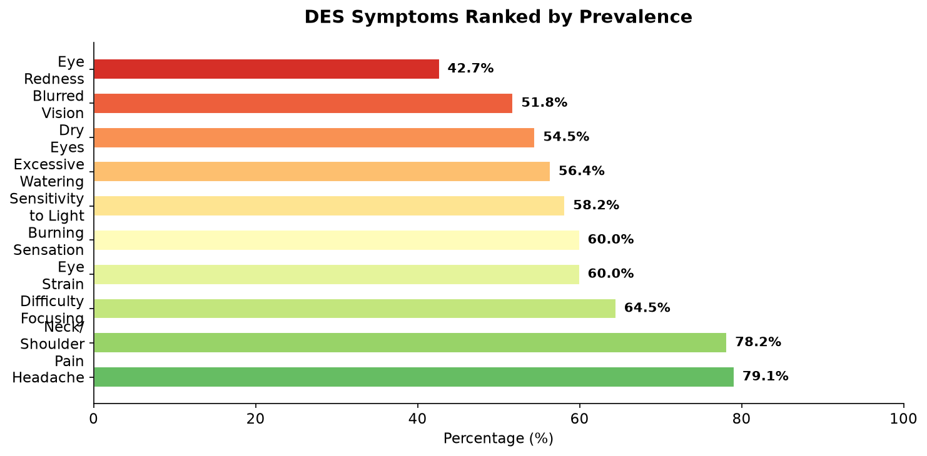

Interpretation: This ranked visualization confirms headache (79.1%) and neck/shoulder pain (78.2%) as the top two symptoms, followed by difficulty focusing (64.5%) and eye strain (60%).

Table 4.14: Frequency of Eye Strain/Tired Eyes
Response | Frequency (n) | Percentage (%)
Never | 17 | 15.5
Rarely | 27 | 24.5
Sometimes | 48 | 43.6
Often | 15 | 13.6
Always | 3 | 2.7
Total | 110 | 100.0

Figure: Frequency of Eye Strain/Tired Eyes - Visual Representation
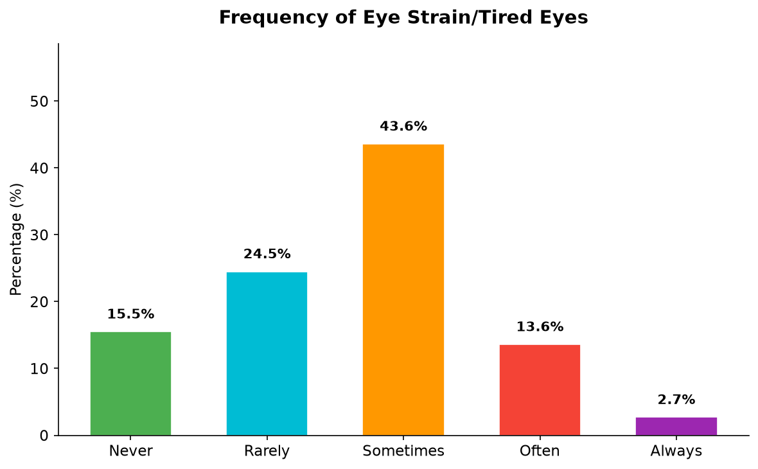

Interpretation: 60% experienced eye strain at least sometimes.
Table 4.15: Frequency of Burning Sensation in Eyes
Response | Frequency (n) | Percentage (%)
Never | 44 | 40.0
Sometimes | 40 | 36.4
Occasionally | 20 | 18.2
Often | 3 | 2.7
Always | 3 | 2.7
Total | 110 | 100.0

Figure: Frequency of Burning Sensation in Eyes - Visual Representation
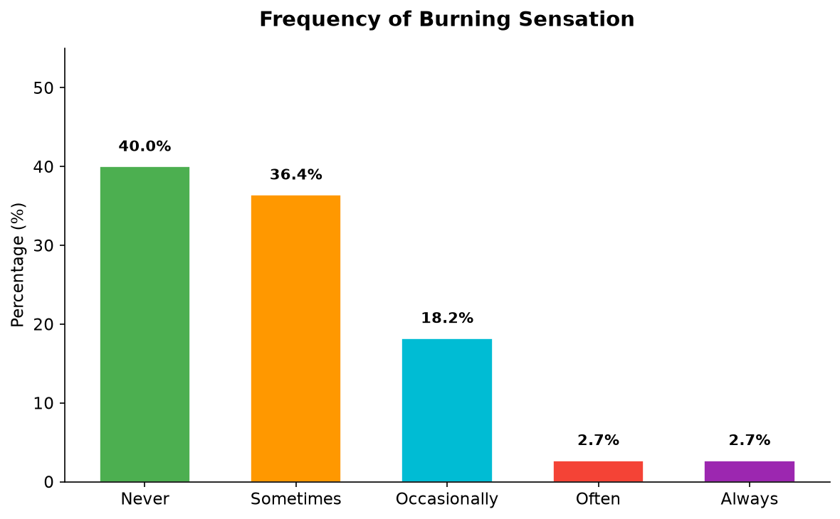

Interpretation: 60% reported burning sensation at least sometimes.
Table 4.16: Frequency of Dry Eyes
Response | Frequency (n) | Percentage (%)
Never | 50 | 45.5
Sometimes | 32 | 29.1
Occasionally | 19 | 17.3
Often | 7 | 6.4
Always | 2 | 1.8
Total | 110 | 100.0

Figure: Frequency of Dry Eyes - Visual Representation
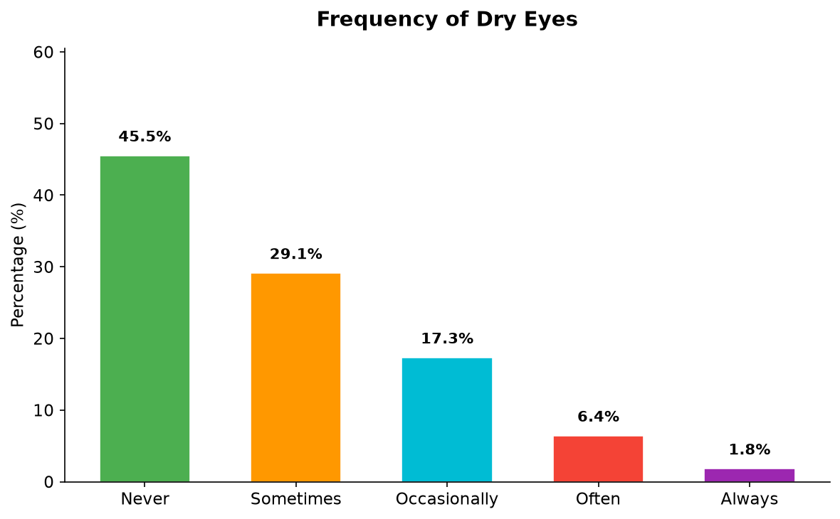

Interpretation: 54.5% experienced dry eyes due to reduced blinking.
Table 4.17: Frequency of Headache After Screen Use
Response | Frequency (n) | Percentage (%)
Never | 23 | 20.9
Rarely | 34 | 30.9
Sometimes | 37 | 33.6
Often | 10 | 9.1
Always | 6 | 5.5
Total | 110 | 100.0

Figure: Frequency of Headache After Screen Use - Visual Representation
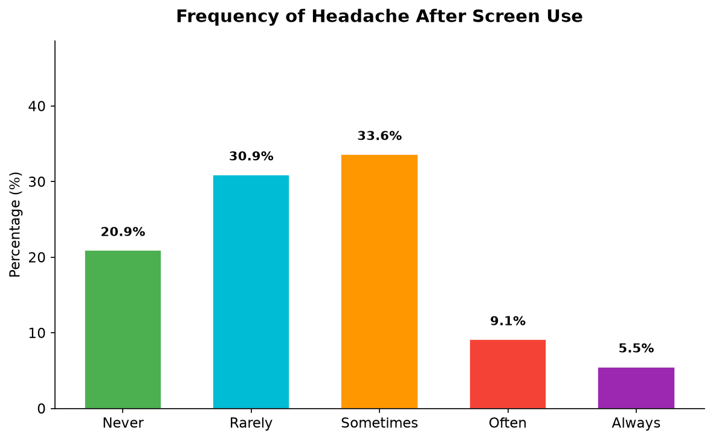

Interpretation: 79.1% reported headaches — the most prevalent symptom.
Table 4.18: Frequency of Blurred Vision
Response | Frequency (n) | Percentage (%)
Never | 53 | 48.2
Sometimes | 24 | 21.8
Occasionally | 27 | 24.5
Often | 5 | 4.5
Always | 1 | 0.9
Total | 110 | 100.0

Figure: Frequency of Blurred Vision - Visual Representation
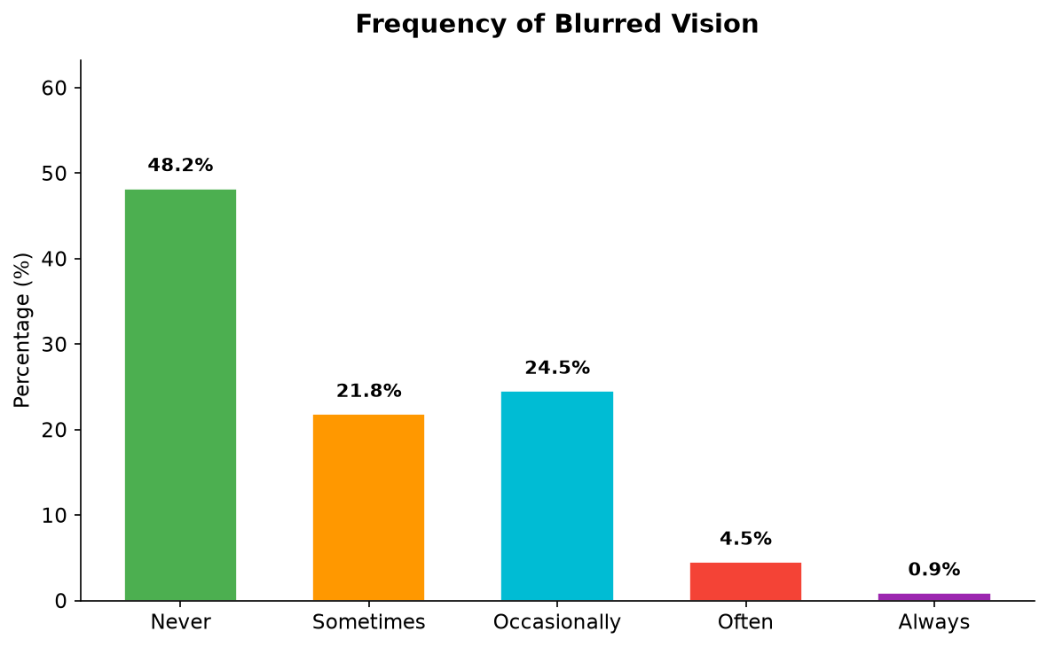

Interpretation: 51.8% experienced blurred vision.
Table 4.19: Frequency of Eye Redness
Response | Frequency (n) | Percentage (%)
Never | 63 | 57.3
Sometimes | 20 | 18.2
Occasionally | 22 | 20.0
Often | 4 | 3.6
Always | 1 | 0.9
Total | 110 | 100.0

Figure: Frequency of Eye Redness - Visual Representation
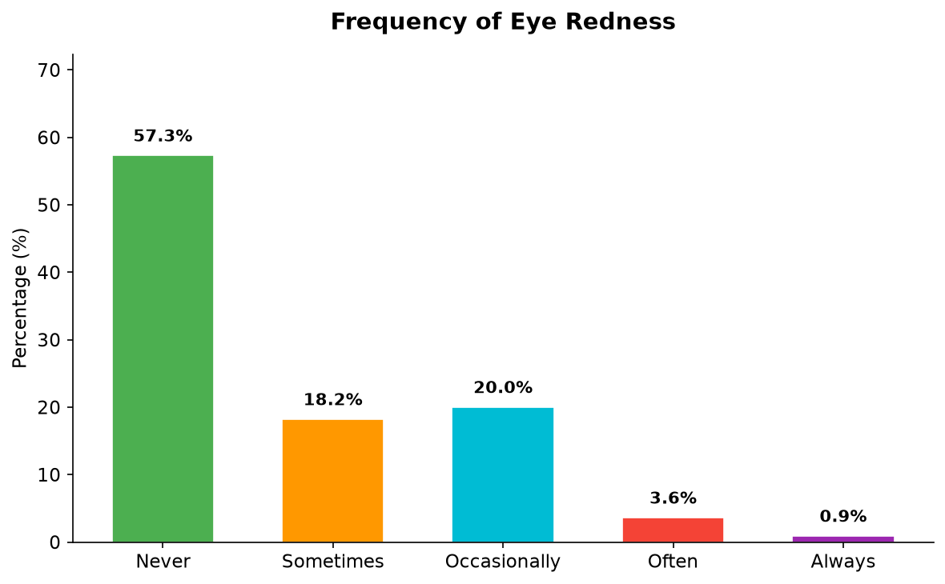

Interpretation: 42.7% reported eye redness.
Table 4.20: Frequency of Neck or Shoulder Pain
Response | Frequency (n) | Percentage (%)
Never | 24 | 21.8
Rarely | 33 | 30.0
Sometimes | 35 | 31.8
Often | 10 | 9.1
Always | 8 | 7.3
Total | 110 | 100.0

Figure: Frequency of Neck or Shoulder Pain - Visual Representation
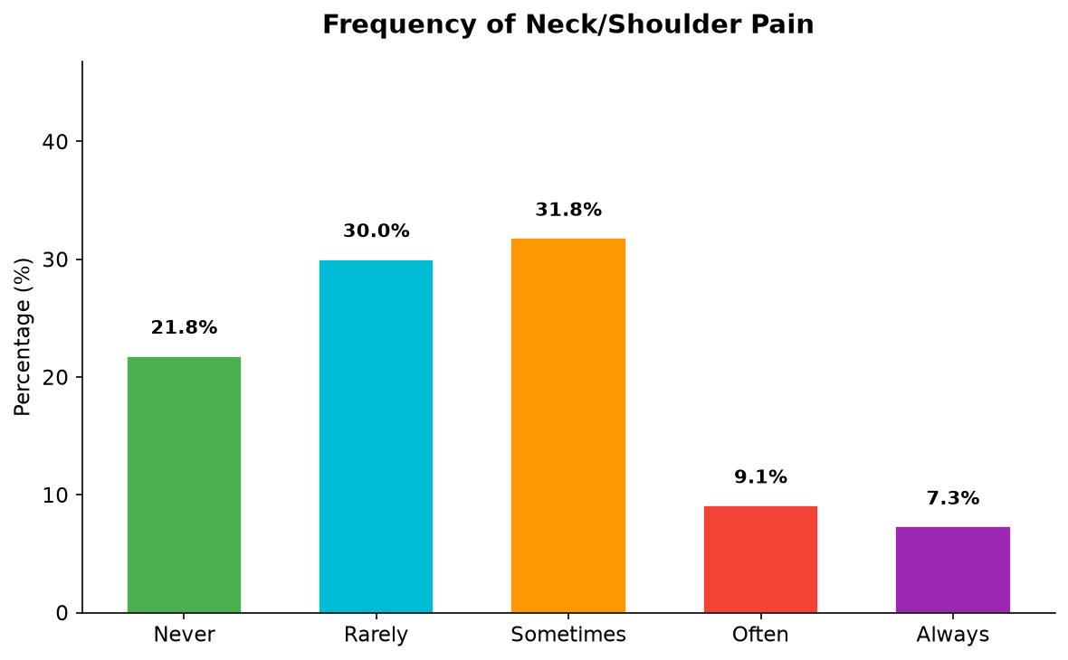

Interpretation: 78.2% experienced neck/shoulder pain, linked to poor posture.
Table 4.21: Frequency of Difficulty Focusing
Response | Frequency (n) | Percentage (%)
Never | 39 | 35.5
Sometimes | 35 | 31.8
Occasionally | 17 | 15.5
Often | 13 | 11.8
Always | 6 | 5.5
Total | 110 | 100.0

Figure: Frequency of Difficulty Focusing - Visual Representation
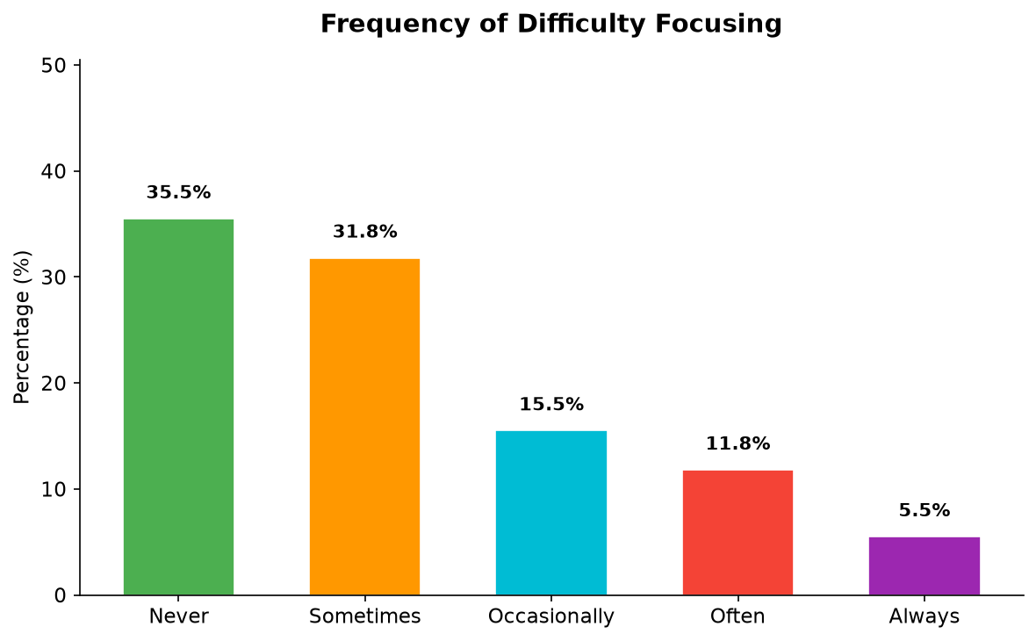

Interpretation: 64.5% reported difficulty focusing, impacting academics.
Table 4.22: Frequency of Sensitivity to Light
Response | Frequency (n) | Percentage (%)
Never | 46 | 41.8
Sometimes | 32 | 29.1
Occasionally | 22 | 20.0
Often | 4 | 3.6
Always | 6 | 5.5
Total | 110 | 100.0

Figure: Frequency of Sensitivity to Light - Visual Representation
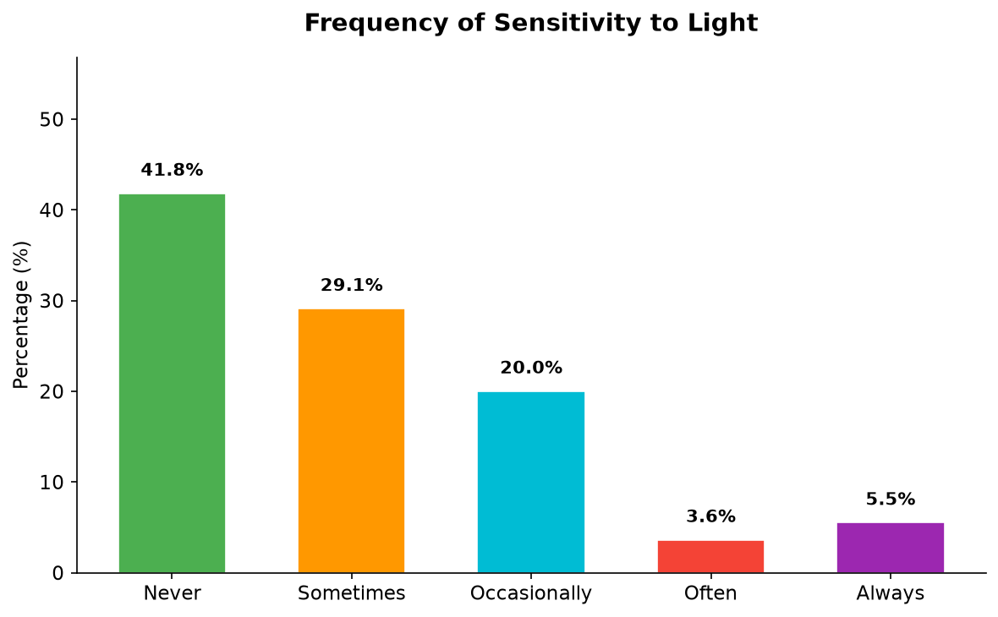

Interpretation: 58.2% experienced light sensitivity.
Table 4.23: Frequency of Excessive Watering/Tearing
Response | Frequency (n) | Percentage (%)
Never | 48 | 43.6
Sometimes | 28 | 25.5
Occasionally | 22 | 20.0
Often | 8 | 7.3
Always | 4 | 3.6
Total | 110 | 100.0

Figure: Frequency of Excessive Watering/Tearing - Visual Representation
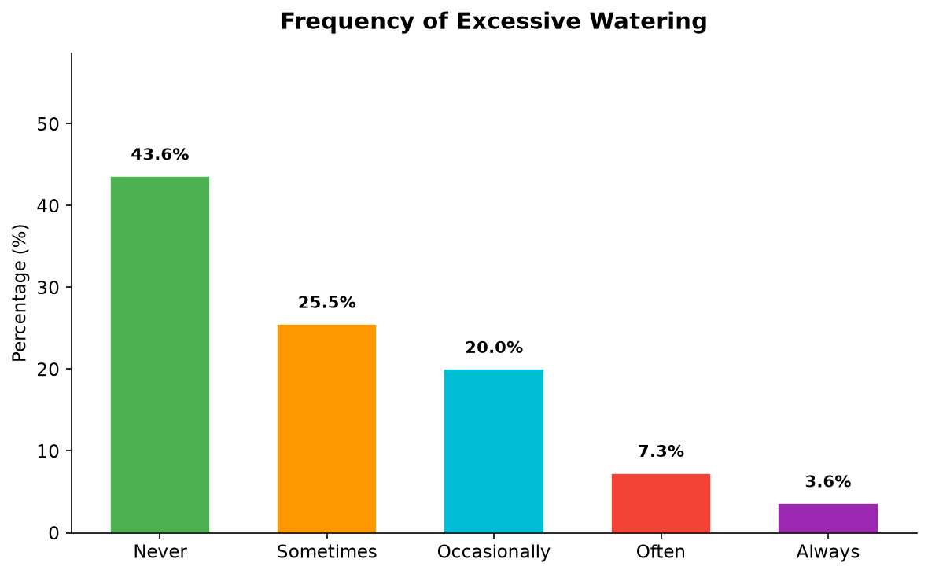

Interpretation: 56.4% experienced excessive tearing.

4.4 Preventive Practices and Awareness
Table 4.24: Following the 20-20-20 Rule (Preventive Practice)
Response | Frequency (n) | Percentage (%)
No | 61 | 55.5
Yes | 25 | 22.7
Sometimes | 24 | 21.8
Total | 110 | 100.0

Figure: Following the 20-20-20 Rule (Preventive Practice) - Visual Representation
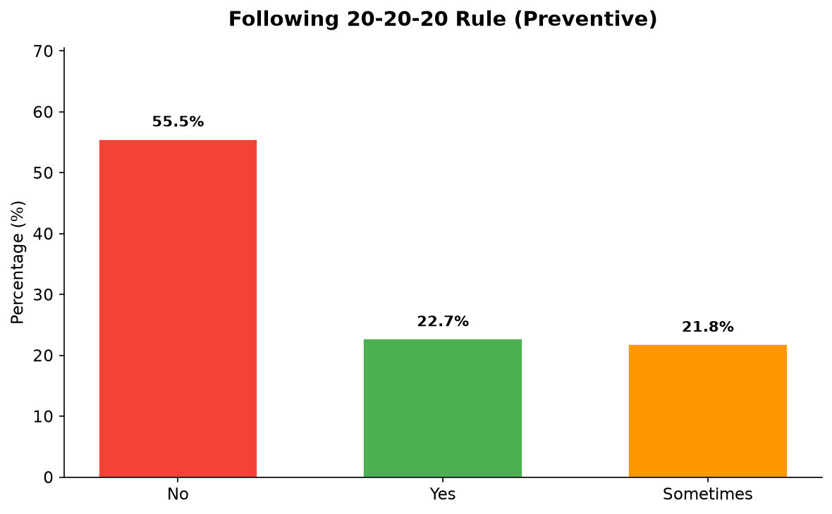

Interpretation: 55.5% did not follow the 20-20-20 rule.
Table 4.25: Use of Artificial Tears or Eye Drops
Response | Frequency (n) | Percentage (%)
No | 80 | 72.7
Yes | 17 | 15.5
Occasionally | 13 | 11.8
Total | 110 | 100.0

Figure: Use of Artificial Tears or Eye Drops - Visual Representation
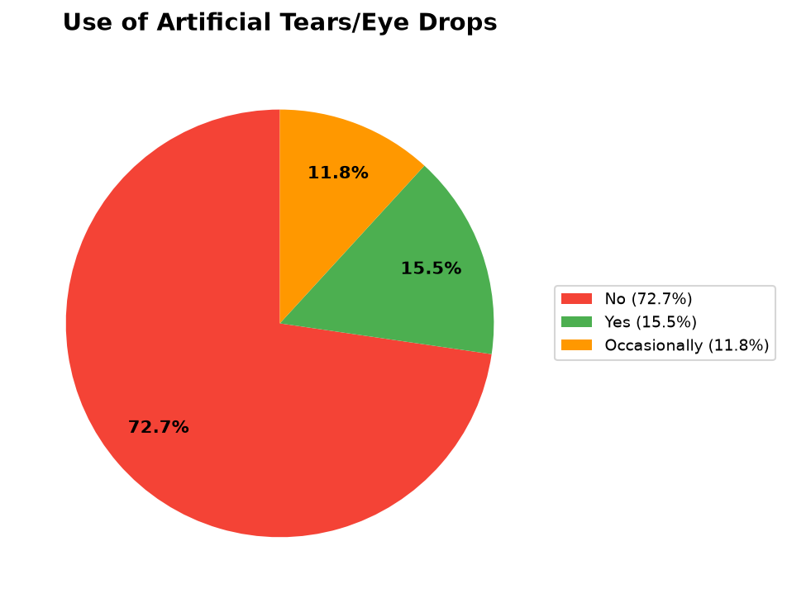

Interpretation: 72.7% did not use artificial tears despite 54.5% having dry eyes.
Table 4.26: Conscious Reduction of Screen Brightness
Response | Frequency (n) | Percentage (%)
Always | 54 | 49.1
Sometimes | 52 | 47.3
Never | 4 | 3.6
Total | 110 | 100.0

Figure: Conscious Reduction of Screen Brightness - Visual Representation
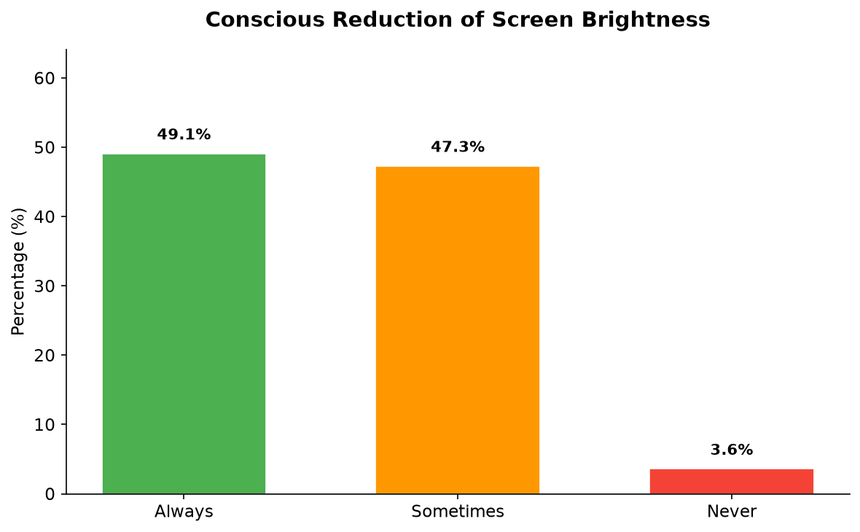

Interpretation: Positive finding: 96.4% adjusted brightness at least sometimes.
Table 4.27: Proper Screen Distance Adjustment
Response | Frequency (n) | Percentage (%)
Yes | 58 | 52.7
No | 34 | 30.9
Sometimes | 18 | 16.4
Total | 110 | 100.0

Figure: Proper Screen Distance Adjustment - Visual Representation
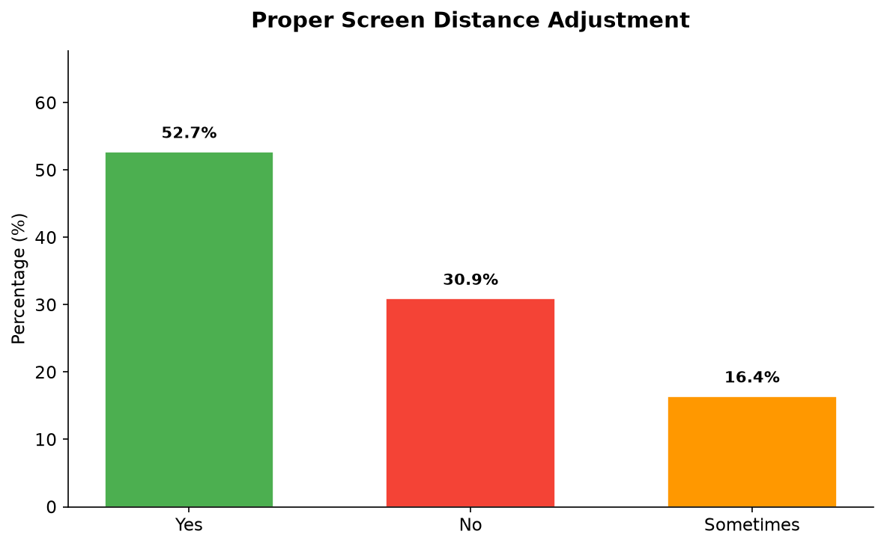

Interpretation: 47.3% did not consistently adjust screen distance.
Table 4.28: Performance of Eye Relaxation Exercises
Response | Frequency (n) | Percentage (%)
No | 72 | 65.5
Yes | 38 | 34.5
Total | 110 | 100.0

Figure: Performance of Eye Relaxation Exercises - Visual Representation
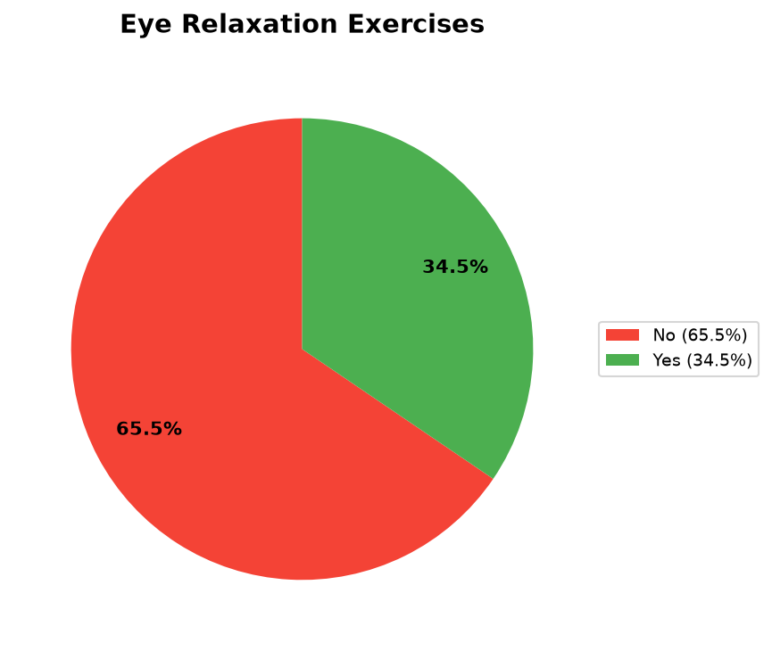

Interpretation: 65.5% did not perform eye relaxation exercises.
Table 4.29: Consultation with Eye Specialist
Response | Frequency (n) | Percentage (%)
No | 50 | 45.5
Yes | 42 | 38.2
Rarely | 18 | 16.4
Total | 110 | 100.0

Figure: Consultation with Eye Specialist - Visual Representation
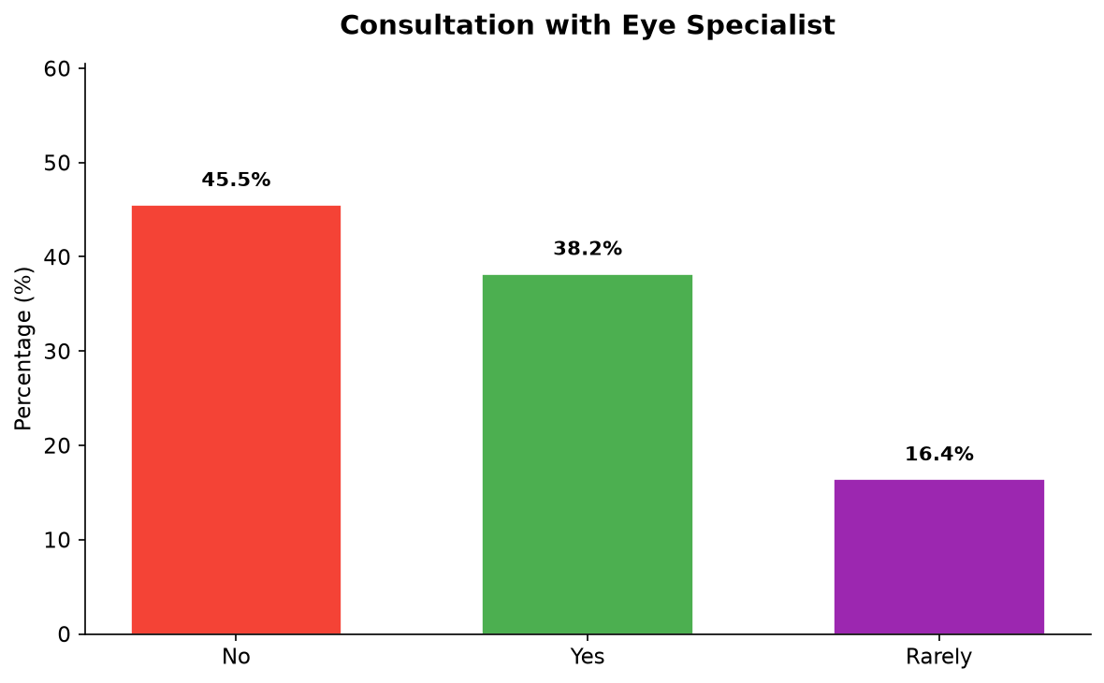

Interpretation: 45.5% did not consult an eye specialist.
Table 4.30: Awareness of Digital Eye Strain
Response | Frequency (n) | Percentage (%)
Yes | 81 | 73.6
No | 29 | 26.4
Total | 110 | 100.0

Figure: Awareness of Digital Eye Strain - Visual Representation
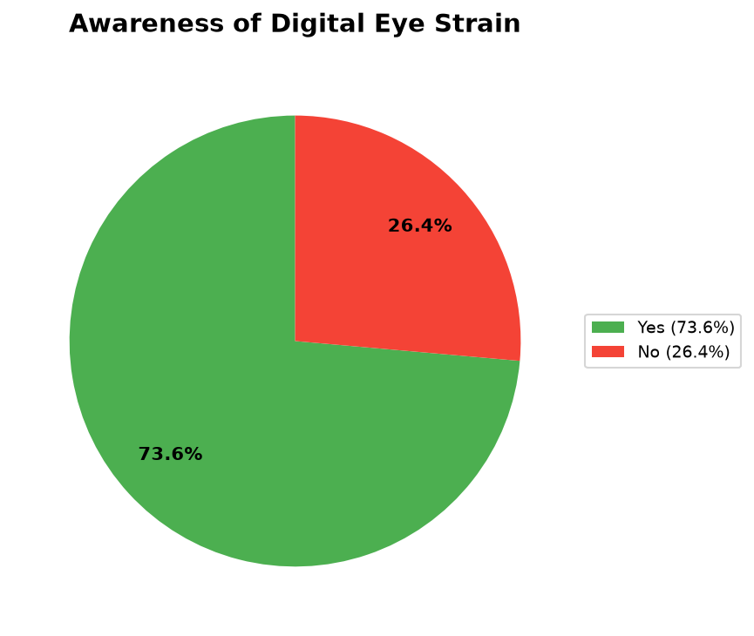

Interpretation: 73.6% were aware of DES.
Table 4.31: Knowledge: Prolonged Screen Use Affects Eye Health
Response | Frequency (n) | Percentage (%)
Yes | 98 | 89.1
No | 12 | 10.9
Total | 110 | 100.0

Figure: Knowledge: Prolonged Screen Use Affects Eye Health - Visual Representation
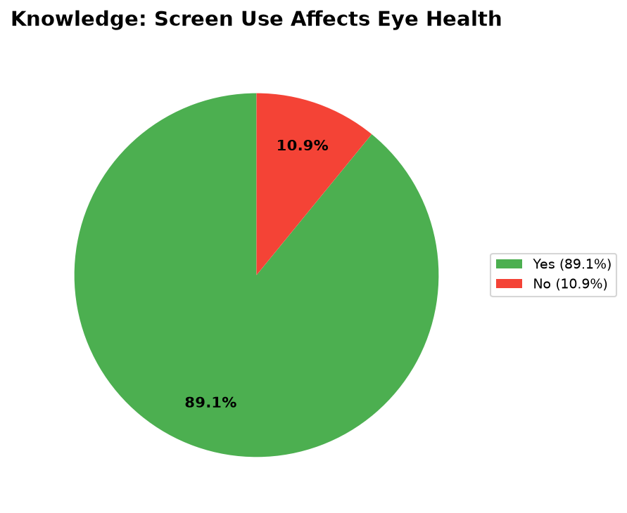

Interpretation: 89.1% knew about effects.
Table 4.32: Knowledge of Preventive Measures
Response | Frequency (n) | Percentage (%)
Yes | 76 | 69.1
No | 34 | 30.9
Total | 110 | 100.0

Figure: Knowledge of Preventive Measures - Visual Representation
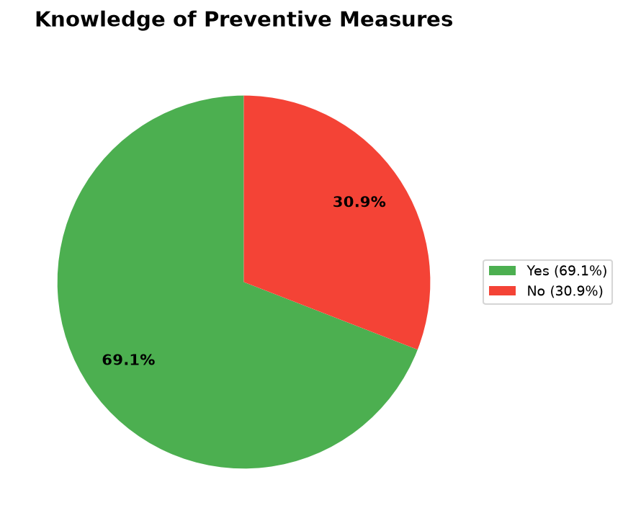

Interpretation: 30.9% did not know about preventive measures.
Table 4.33: Previous Education/Training on Eye Care
Response | Frequency (n) | Percentage (%)
No | 70 | 63.6
Yes | 39 | 35.5
Other | 1 | 0.9
Total | 110 | 100.0

Figure: Previous Education/Training on Eye Care - Visual Representation
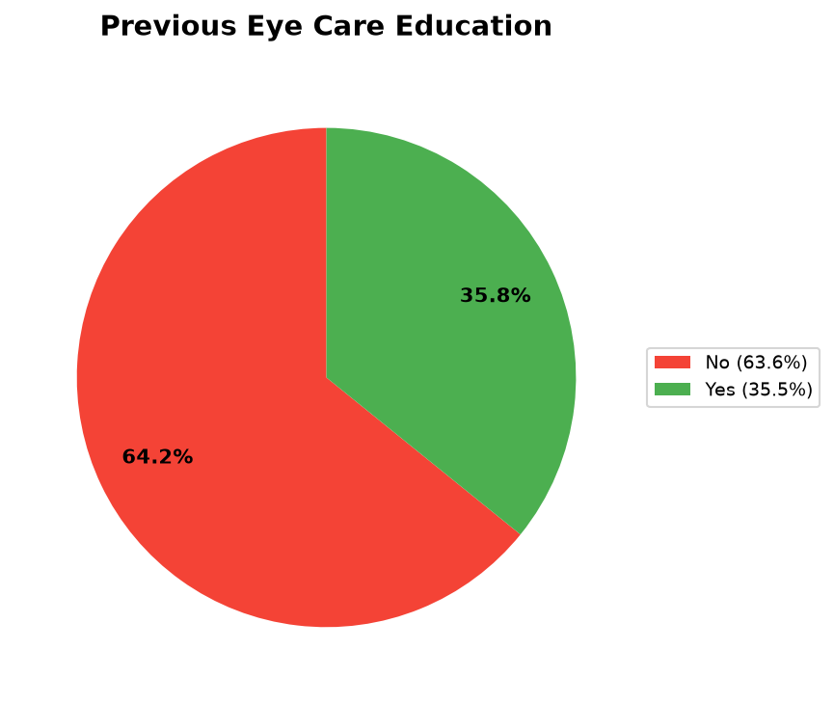

Interpretation: 63.6% never received eye care education.

